CREATE TABLE Stud_Marks (
name VARCHAR(50),
total_marks INT
);

CREATE TABLE Result (
roll INT PRIMARY KEY AUTO_INCREMENT,
name VARCHAR(50),
class VARCHAR(30)
);

INSERT INTO Stud_Marks (name, total_marks) VALUES ('Alice', 1450);
INSERT INTO Stud_Marks (name, total_marks) VALUES ('Bob', 980);
INSERT INTO Stud_Marks (name, total_marks) VALUES ('Charlie', 875);
INSERT INTO Stud_Marks (name, total_marks) VALUES ('David', 820);
INSERT INTO Stud_Marks (name, total_marks) VALUES ('Eve', 920);

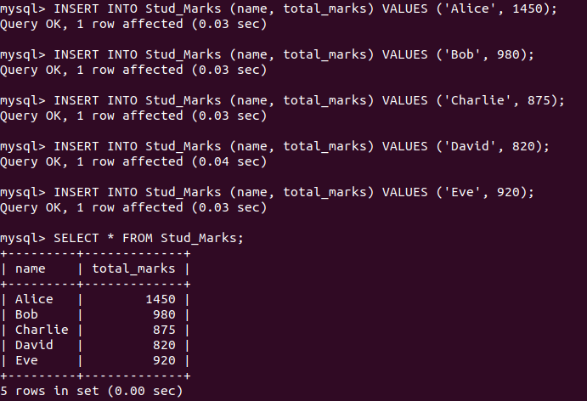



DELIMITER $$

CREATE PROCEDURE proc_Grade()
BEGIN
DELETE FROM Result; -- clear previous data if any

INSERT INTO Result (name, class)
SELECT
name,
CASE
WHEN total_marks BETWEEN 990 AND 1500 THEN 'Distinction'
WHEN total_marks BETWEEN 900 AND 989 THEN 'First Class'
WHEN total_marks BETWEEN 825 AND 899 THEN 'Higher Second Class'
ELSE 'No Category'
END AS class
FROM Stud_Marks;
END $$

DELIMITER ;

